Exp no:6 Determination and plotting of Capacitance of parallel plate capacitor in three different
dielectric medium with specific area, dielectric thickness and various dielectric constants.
Aim:
To write program for capacitance of parallel plate capacitor in three different dielectric medium with
specific area, dielectric thickness and various dielectric constants using MATLAB.
Software required:
•MATLAB (R2018 or later)
Test case
(i) Determination and plotting of capacitance of parallel plate capacitor for given area and
dielectric thickness
Program:
clc;
clear;
A=input("Enter the area value=");
d=input("Enter the thickness value=");
epsilon0=8.854*10^-12;
C=epsilon0*A/d;
disp('The capacitance is');
disp(C);
% Plot
x = linspace(0,10,50);
y = C * exp(-0.1 * x);
figure;
plot(x,y,'LineWidth',2);
xlabel('distance');
ylabel('capacitance');
title('Parallel plate capacitance');
Output:-
Enter the area value = 8e-4
Enter the thickness value = 3e-3
The capacitance is
2.36 × 10⁻¹² F
Test case (ii) Determination of capacitance of parallel plate capacitor with three different
dielectric layers
Program:
clc;
A=input("Enter the area value=");
d1=input("Enter thickness d1=");
d2=input("Enter thickness d2=");
d3=input("Enter thickness d3=");
er1=input("Enter dielectric constant er1=");
er2=input("Enter dielectric constant er2=");
er3=input("Enter dielectric constant er3=");
epsilon0=8.854e-12;
C=epsilon0*A/((d1/er1)+(d2/er2)+(d3/er3));
disp('The capacitance is');
disp(C);
OUTPUT:
Enter the area value = 8e-4
Enter thickness d1 = 1e-3
Enter thickness d2 = 3e-3
Enter thickness d3 = 2e-3
Enter dielectric constant er1 = 2.3
Enter dielectric constant er2 = 3.3
Enter dielectric constant er3 = 4
The capacitance is
3.84 × 10⁻¹² F
Output
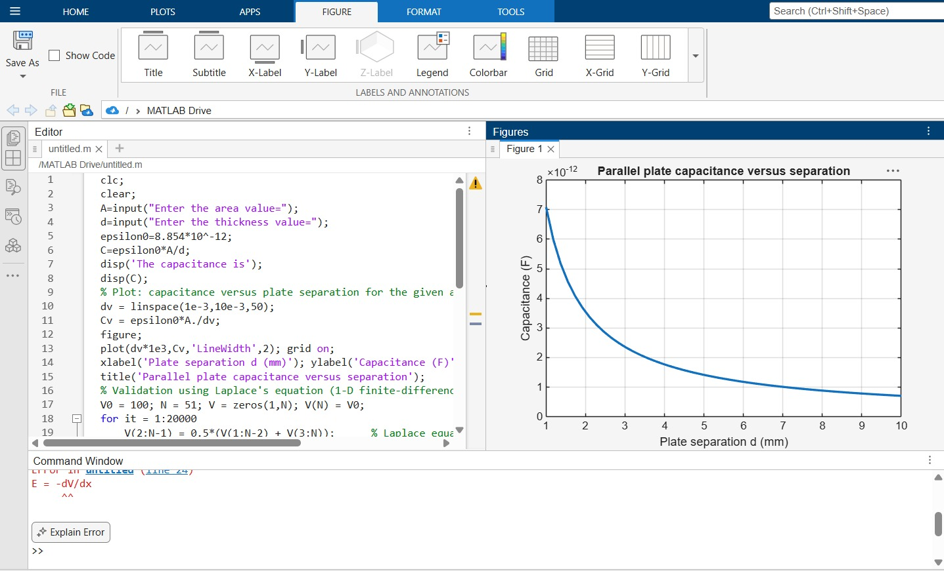
Test case (ii) Determination of capacitance of parallel plate capacitor with three different
dielectric layers
Program:
clc;
A=input ("Enter the area value=");
d1=input ("Enter thickness d1=");
d2=input ("Enter thickness d2=");
d3=input ("Enter thickness d3=");
er1=input ("Enter dielectric constant er1=");
er2=input ("Enter dielectric constant er2=");
er3=input ("Enter dielectric constant er3=");
epsilon0=8.854e-12;
C=epsilon0*A/((d1/er1) +(d2/er2) +(d3/er3));
disp('The capacitance is');
disp(C);
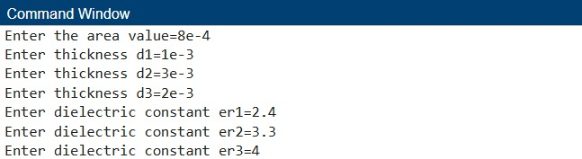
Test case (iii) Determination and plotting of capacitance variation with dielectric constant (Air)
Program:
clc;
epsilon0 = 8.854e-12;
A = 1e-4;
d = 1e-3;
er = linspace(1,1.5,100);
C = (epsilon0 .* er .* A) ./ d;
plot(er,C,'LineWidth',2);
xlabel('Dielectric constant');
ylabel('Capacitance');
title('Capacitance vs dielectric constant (Air)');
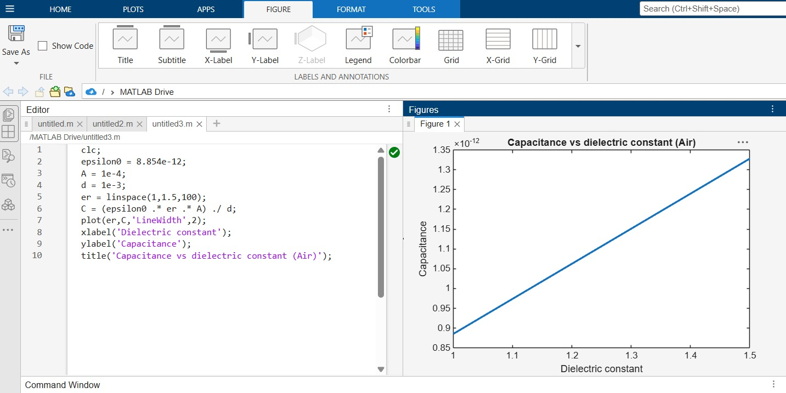
Test case (iv) Determination and plotting of capacitance variation with dielectric
constant (Glass)
clc;
epsilon0 = 8.854e-12;
A = 1e-4;
d = 1e-3;
er = linspace(4,8,100);
C = (epsilon0 .* er .* A) ./ d;
plot(er,C,'LineWidth',2);
xlabel('Dielectric constant');
ylabel('Capacitance');
title('Capacitance vs dielectric
constant (Glass)');
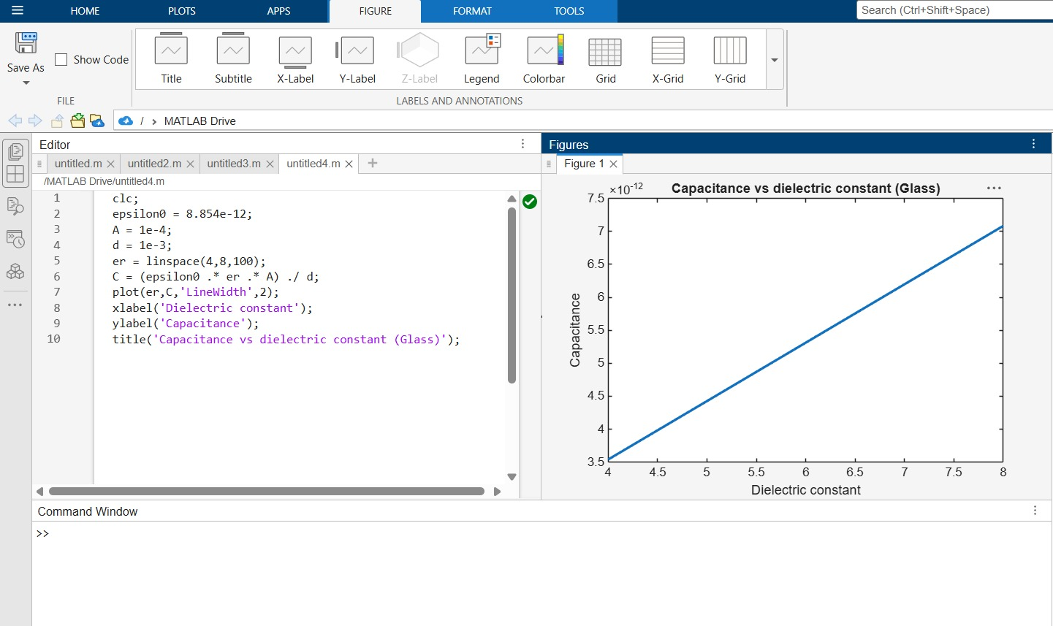
Result
Thus the program was verified for capacitance of parallel plate capacitor in different dielectric medium using MATLAB was successfully. 